**Math 32**

Lecture 3: Complements

Simple example: Unless otherwise noted, the coin flip has two disjoint outcomes---“heads” or “tails”---with probabilities

* P(heads) = ½
* P(tails) = ½



image credit:

“How to Flip a Coin: 11 Steps (with pictures)” at wikiHow

Two coins: 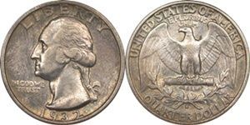

Thought question:   
How should the sample space for a trial of flipping two coins be represented?

1. {two heads, mixed result, two tails}
2. {HH, HT, TH, TT}

Answer: choice (B) is correct. How? Later shown empirically (i.e. by computer simulations)

Definition: The set of all possible outcomes for an event is called the **universal set**. It is usually denoted by the Greek letter capital omega. For example, the set of all outcomes for two coin flips of a fair coin is

Also, in the definition of sets,

* Each element is its only copy (duplicates would have to be explicitly shown)
* Order does not matter

Today’s sets

* Let set A be the blue rectangle
* Let set B be the red triangle

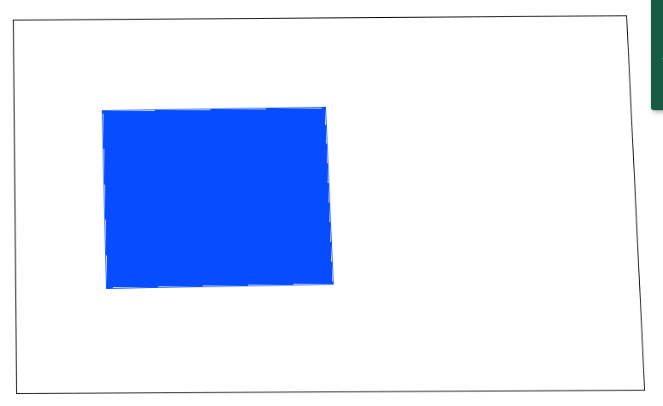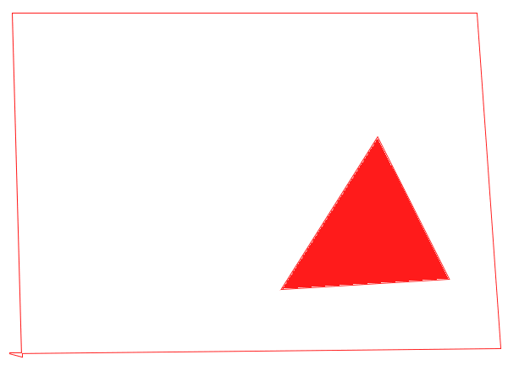

Definition: If A is a set (and a subset of the universal set), then the **complement** of A is the set of outcomes that is in the universal set but not in the set A.

* We say that is the set complement of A
* We say that is the set complement of B

 

Technically: if , then

Example: For the roll of a six-sided die, if E = {2, 4, 6}, then what is the complement of E?

* Universal set:
* E = {2, 4, 6}

**De Morgan’s Law**

The complement of the union is the intersection of the complements

The mathematical proof is quite intense. Instead, we are going to do a “proof by picture” to rather show the idea (but not a real proof)

First, we look at the left-hand-side (LHS)

Recall that sets A and B were defined above as



Next, we will look at the union

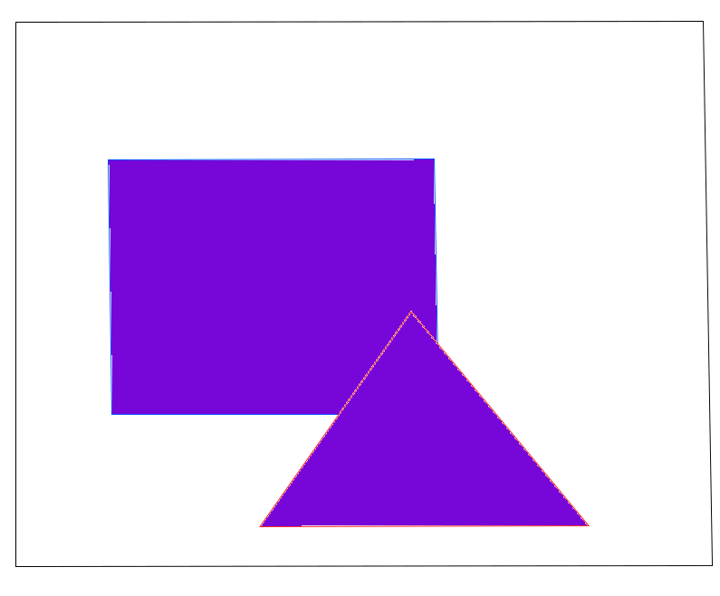

Finally, we take the complement to get

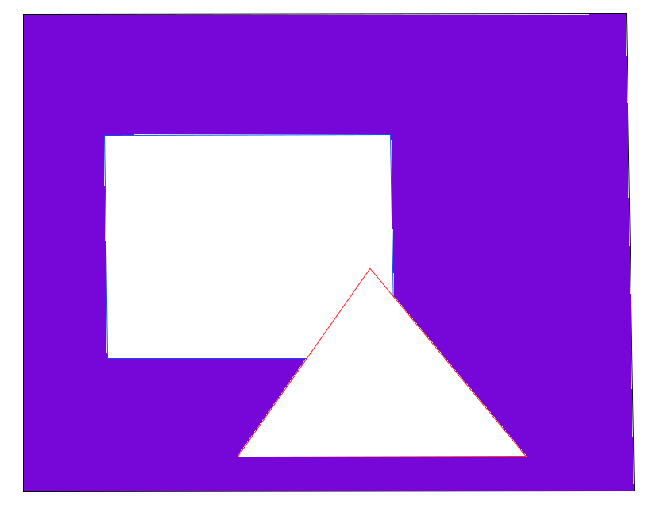

First, we look at the right-hand-side (RHS)

Recall that sets A and B were defined above as



The complements were



Finally, we compute the intersection



We have shown (at least, through “proof by picture”) that De Morgan’s Law holds

= 

What is probability?

(at least) two schools of thought: frequentist and Bayesian

The **frequentist** approach is that we assume that we can run an infinite number of trials to observe an event C. If n is the number of trials, and c is the number of times we observe the event C as we conduct trials, then as n increases,

